# Practice Test 1

### **Question 1**

Domain :Design Azure data storage solutions

A company is planning to deploy two Cosmos DB databases named compdb1 and compdb2. Below are the requirements for the databases.

* Costs must be minimized for both databases.
* The database compdb1 must meet an SLA of 99.99% for both reads and writes.
* The database compdb2 must meet an SLA of 99.99% for writes and 99.999% for reads.

Which of the following would you implement for the database compdb1?

]A.

**A single read/write region**

]B.

**A single read region and multiple writes**

]C.

**A single write region and multiple reads**

]D.

**Multiple read regions and multiple write regions**

**Explanation:**

Answer – A

Since you just want 99.99% for both reads and writes, you can opt for just a single read and write region. This would also be a cost-efficient option and fulfill the requirement.

The Microsoft documentation mentions the following.

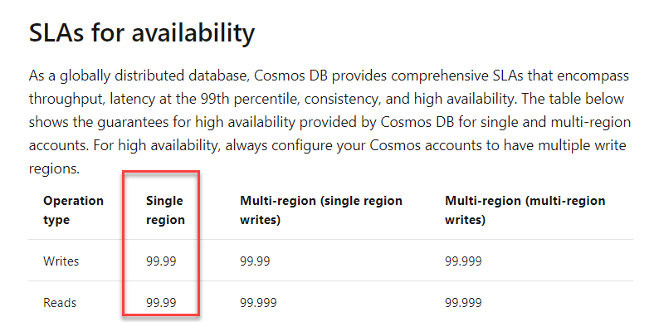

Since this is clearly mentioned in the documentation, all other options are incorrect.

For more information on high availability for Cosmos DB, please visit the below URL-

* <https://docs.microsoft.com/en-us/azure/cosmos-db/high-availability>

### **Question 2**

Domain :Design Azure data storage solutions

A company is planning to deploy two Cosmos DB databases named compdb1 and compdb2. Below are the requirements for the databases.

* Costs must be minimized for both databases.
* The database compdb1 must meet an SLA of 99.99% for both reads and writes.
* The database compdb2 must meet an SLA of 99.99% for writes and 99.999% for reads.

Which of the following would you implement for the database compdb2?

]A.

**A single read/write region**

]B.

**A single read region and multiple writes**

]C.

**A single write region and multiple reads**

]D.

**Multiple read regions and multiple write regions**

**Explanation:**

Answer – C

Here you can have multiple regions for reading to meet the requirement.

The Microsoft documentation mentions the following.

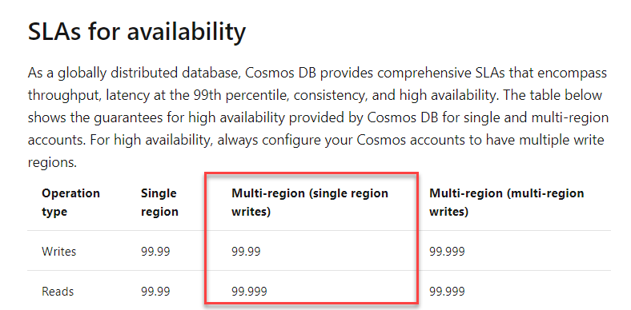

Since this is clearly mentioned in the documentation, all other options are incorrect.

For more information on high availability for Cosmos DB, please visit the below URL-

* <https://docs.microsoft.com/en-us/azure/cosmos-db/high-availability>

### **Question 3**

Domain :Design for data security and compliance

A company has set an Azure SQL data warehouse. They want to ensure that users use two-factor authentication when they access data from the data warehouse using SQL Server Management Studio. Which of the following would you implement for this requirement?

]A.

**Azure AD Privileged Identity Management**

]B.

**Azure AD Identity Protection**

]C.

**Azure Key Vault**

]D.

**Azure conditional access policies**

**Explanation:**

Answer – D

You use conditional access policies to enable Multi-Factor authentication.

The Microsoft documentation mentions the following.

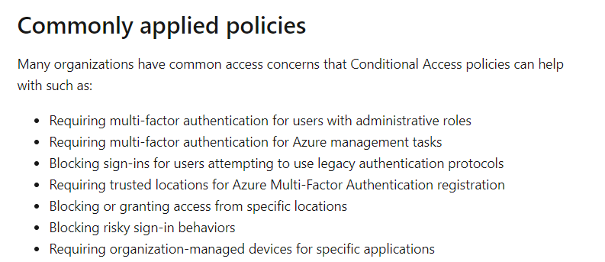

Since this is clearly mentioned in the documentation, all other options are incorrect.

For more information on conditional access, please visit the below URL-

* <https://docs.microsoft.com/en-us/azure/active-directory/conditional-access/overview>

### **Question 4**

Domain :Design for data security and compliance

A company wants to make use of Azure Databricks and Azure Data Lake Storage Gen2. As a data engineer, you have to ensure that the data in the Data Lake Storage is accessed by using a service principal from Azure Databricks. Which of the following would you implement for this requirement?

]A.

**Use the shared access signature in Data Lake Storage.**

]B.

**Use access keys in Data Lake Storage.**

]C.

**Create an application registration in Azure AD.**

]D.

**Use a secret from Azure Key vault.**

**Explanation:**

Answer – C

You have to create an application registration in Azure. Then use the service principal to access Azure Data Lake Gen2 storage.

The data bricks documentation mentions the following.

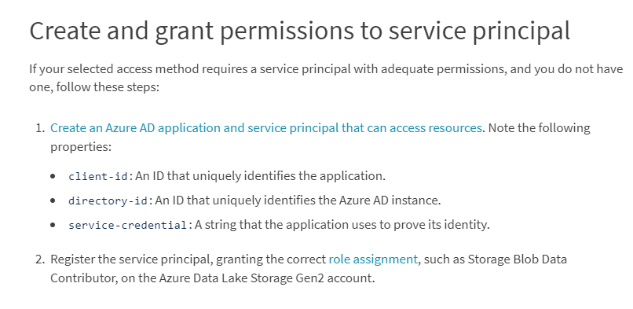

Since this is clearly mentioned in the documentation, all other options are incorrect.

For more information on Data Lake Gen2 access, please visit the below URL-

* <https://docs.databricks.com/data/data-sources/azure/azure-datalake-gen2.html>

### **Question 5**

Domain :Design for data security and compliance

You have an Azure Storage Account of the kind general purpose v2. You have to grant anonymous access permission to access the blobs in a specific container only. Which of the following should you use for this requirement?

]A.

**Access keys for the storage account**

]B.

**A shared access signature**

]C.

**Role based access control**

]D.

**Public access level for the blob service**

**Explanation:**

Answer – B

The most secure way is to use a shared access signature.

The Microsoft documentation mentions the following.

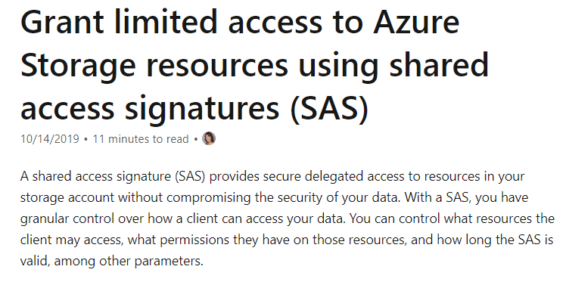

Option A is incorrect since this would give access to the entire storage account.

Option C is incorrect since this is used for control place permissions to the storage account.

Option D is incorrect since this would give access to the entire blob service.

For more information on shared access signature, please visit the below URL-

* <https://docs.microsoft.com/en-us/azure/storage/common/storage-sas-overview>

### **Question 6**

Domain :Design for data security and compliance

You are going to create an Azure SQL data warehouse that is going to container customer data. You need to design a solution with the following requirements.

* Provide the ability for data engineers to view all the rows for the customers.
* The data engineers should not be able to view the credit card information of the customers.

Which of the following would you implement for this requirement?

]A.

**Row-level security**

]B.

**Data masking**

]C.

**Column-level security**

]D.

**Always Encrypted**

**Explanation:**

Answer – B

You can use data masking to make sure that the data engineers can’t access the data.

The Microsoft documentation mentions the following.

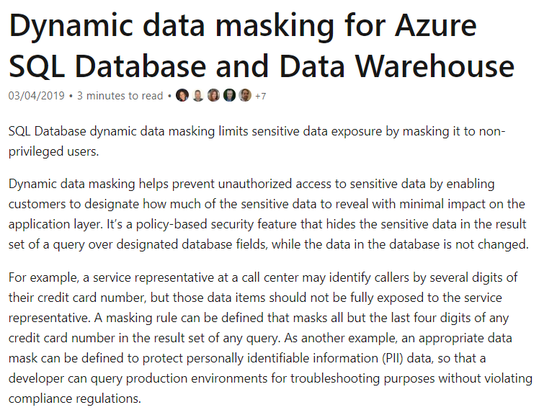

The others are all incorrect since they don’t have data masking capabilities.

For more information on dynamic data masking, please visit the below URL-

* <https://docs.microsoft.com/en-us/azure/sql-database/sql-database-dynamic-data-masking-get-started>

### **Question 7**

Domain :Design data processing solutions

A company wants to implement a big data solution on the Azure platform. The solution must meet the following requirements.

* Must be optimized to carry out batch processing activities.
* Must support autoscaling.
* Must support scaling at the cluster level.

Which of the following would you implement for this requirement?

]A.

**Azure Data warehouse**

]B.

**Azure HDInsight with Spark**

]C.

**Azure Analysis services**

]D.

**Azure Databricks**

**Explanation:**

Answer – D

Azure Databricks can be used for batch processing activities and supports autoscaling as well.

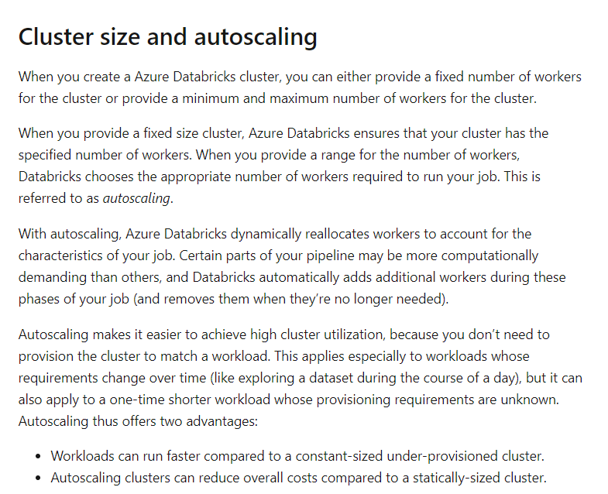

Option A is incorrect since this is a data warehousing solution.

Option B is incorrect since Azure data bricks have the option of scaling clusters.

Option C is incorrect since this is a PaaS service for creating enterprise-grade data models in the cloud.

For more information on configuring Azure data bricks clusters, please visit the below URL-

* <https://docs.microsoft.com/en-us/azure/databricks/clusters/configure#--cluster-size-and-autoscaling>

### **Question 8**

Domain :Design Azure data storage solutions

A company has an Azure SQL Data warehouse. The company wants to have a solution in place wherein the data would be available at the time of a data center failure. The recovery point objective for the data should be an hour. Which of the following would you implement for this solution? Choose 3 answers from the options given below.

A.

**Restore the data warehouse from a geo-redundant backup.**

B.

**Restore the data warehouse from a user-defined restore point.**

C.

**Ensure that any application connection strings are updated to the recovered data warehouse.**

D.

**Ensure to modify the Azure Firewall rules of the data warehouse.**

E.

**Ensure to create Azure Firewall rules to allow access to the restored data warehouse.**

**Explanation:**

Answer – B, C and E

You can restore the data warehouse from a restore point.

Then ensure to create Azure Firewall rules to allow access to the restored data warehouse.

Finally, also ensure any application connection strings are updated to the recovered data warehouse.

Option A is incorrect since the RPO for a geo-redundant backup is 24 hours and does not meet the requirement of 1 hour for the data.

Option D is incorrect since you need to create firewall rules for the restored data warehouse.

For more information on backup and restore for Azure SQL data warehouse, please visit the below URL-

* <https://docs.microsoft.com/en-us/azure/sql-data-warehouse/backup-and-restore>

### **Question 9**

Domain :Design for data security and compliance

A company has an Azure Data Lake Storage Gen 2 account that is used to store data used by data engineers. The data engineers would query the data by using notebooks from Azure data bricks. The folders in the Data Lake storage account would be secured by ensuring that users only have access to the folders they require.

Which of the following would you use as the authentication method for Azure Databricks?

]A.

**Azure Active Directory**

]B.

**Azure Key vault secrets**

]C.

**Personal Access token**

]D.

**Storage access keys**

**Explanation:**

Answer – C

To authenticate, you can use personal access tokens.

The Microsoft documentation mentions the following.

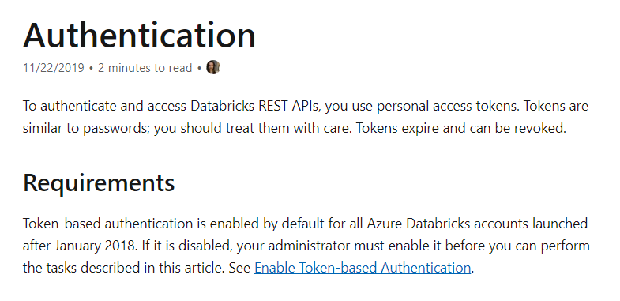

Since this is clearly mentioned in the Microsoft documentation, all other options are incorrect.

For more information on Azure data bricks authentication, please visit the below URL-

* <https://docs.microsoft.com/en-us/azure/databricks/dev-tools/api/latest/authentication>

### **Question 10**

Domain :Design for data security and compliance

A company has an Azure Data Lake Storage Gen 2 account used to store data used by data engineers. The data engineers would query the data by using notebooks from Azure data bricks. The folders in the Data Lake storage account would be secured by ensuring that users only have access to the folders they require.

Which of the following would you use as the authentication method for Data Lake storage?

]A.

**Azure Active Directory**

]B.

**Shared access keys**

]C.

**Shared access signatures**

]D.

**Storage access keys**

**Explanation:**

Answer – A

You can authenticate Azure Data Lake from Azure Databricks using Azure AD credentials.

The Microsoft documentation mentions the following.

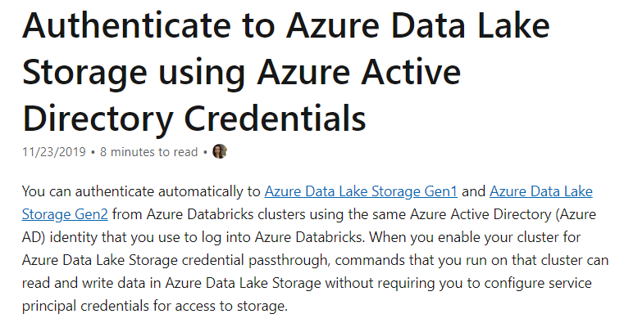

Since this is clearly mentioned in the Microsoft documentation, all other options are incorrect.

For more information on Azure AD authentication for Azure Data Lake Gen 2, please visit the below URL-

* <https://docs.microsoft.com/en-us/azure/databricks/data/data-sources/azure/adls-passthrough>

### **Question 11**

Domain :Design for data security and compliance

A company is planning to set up an Azure SQL database. The database will be used to store sensitive data. Below are the requirements for the data store.

* Only the application accessing the data can perform the encryption.
* The client application must have the access keys for encrypting and decrypting the data.
* The data must not appear in plaintext in the database.
* The strongest encryption method must be used on the database.
* The application should be able to search on select data values.

Which of the following would you use as the encryption method for Searchable data?

]A.

**Always Encrypted with randomized encryption**

]B.

**Always Encrypted with deterministic encryption**

]C.

**CREATE SYMMETRIC KEY statement**

]D.

**CREATE CERTIFICATE statement**

**Explanation:**

Answer – B

The strongest encryption technique is to use Always Encrypted. This will encrypt the data at rest.

If you need to perform a search on the data, you need to use deterministic encryption.

The Microsoft documentation mentions the following.

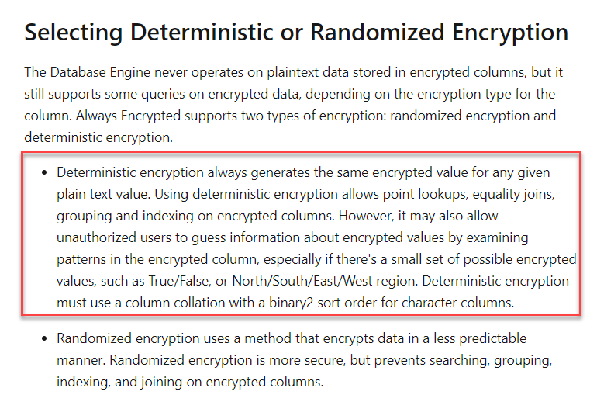

Since this is clearly mentioned in the Microsoft documentation, all other options are incorrect.

For more information on Always Encrypted, please visit the below URL-

* <https://docs.microsoft.com/en-us/sql/relational-databases/security/encryption/always-encrypted-database-engine?view=sql-server-ver15>

### **Question 12**

Domain :Design for data security and compliance

A company is planning to set up an Azure SQL database. The database will be used to store sensitive data. Below are the requirements for the data store.

* Only the application accessing the data can perform the encryption.
* The client application must have the access keys for encrypting and decrypting the data.
* The data must not appear in plaintext in the database.
* The strongest encryption method must be used on the database.
* The application should be able to search on select data values.

Which of the following would you use as the encryption method for Non-Searchable data?

]A.

**Always Encrypted with randomized encryption**

]B.

**Always Encrypted with deterministic encryption**

]C.

**CREATE SYMMETRIC KEY statement**

]D.

**CREATE CERTIFICATE statement**

**Explanation:**

Answer – A

The strongest encryption technique is to use Always Encrypted. This will encrypt the data at rest.

For non-searchable data, you can use randomized encryption for the strongest possible encryption.

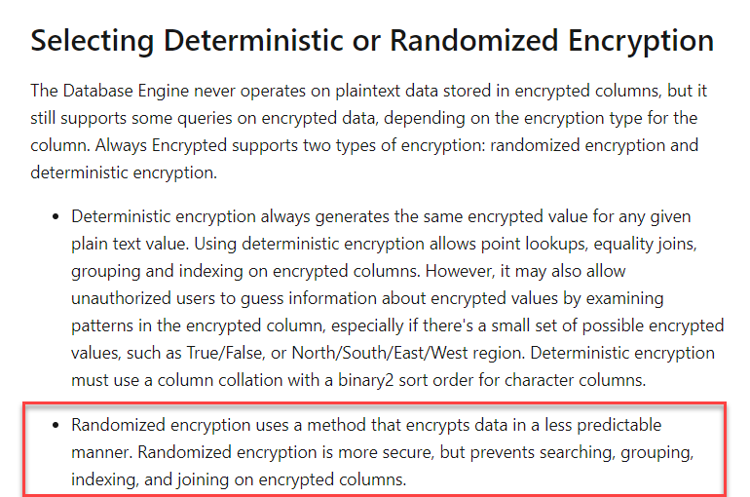

Since this is clearly mentioned in the Microsoft documentation, all other options are incorrect.

For more information on Always Encrypted, please visit the below URL-

* <https://docs.microsoft.com/en-us/sql/relational-databases/security/encryption/always-encrypted-database-engine?view=sql-server-ver15>

### **Question 13**

Domain :Design data processing solutions

A company is planning to design a solution in Azure. The solution would be based on the Lambda architecture as shown below.

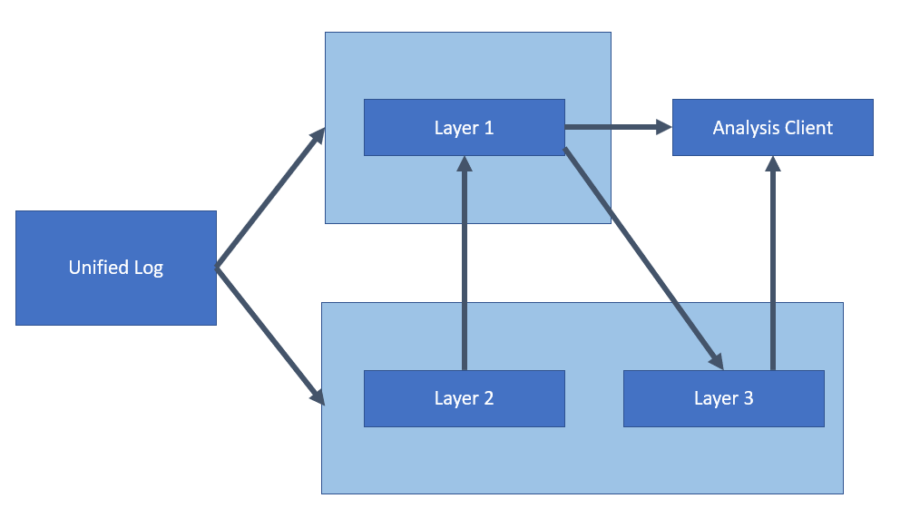

Which of the following service would you use for Layer 2?

]A.

**Azure Data Lake Storage Gen 2**

]B.

**Azure Event Hubs**

]C.

**Azure Log Analytics**

]D.

**Azure SQL Data Warehouse**

**Explanation:**

Answer – A

If you look at the Lambda architecture in the Microsoft documentation, Layer 2 corresponds to a batch layer wherein you can store master data. Here the data is stored in its raw form. Azure Data Lake Storage Gen 2 would be ideal as the underlying data lake store.

The Microsoft documentation mentions the following.

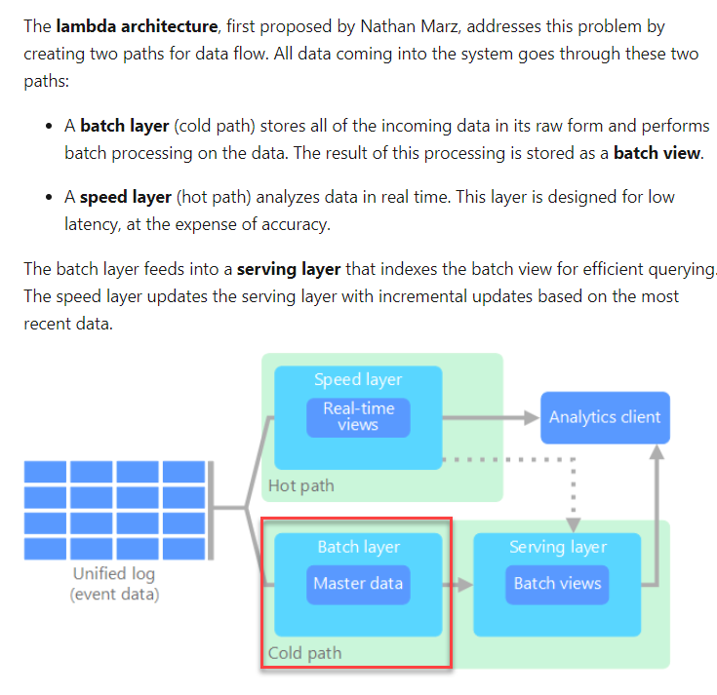

Option B is incorrect since this should be used for ingesting data.

Option C is incorrect since this is used for analyzing data.

Option D is incorrect since this is used as a data warehousing solution where you can perform analytics.

For more information on Big Data architectures, please visit the below URL-

* <https://docs.microsoft.com/en-us/azure/architecture/data-guide/big-data/>

### **Question 14**

Domain :Design data processing solutions

A company is planning to design a solution in Azure. The solution would be based on the Lambda architecture as shown below.



Which of the following service would you use for Layer 3?

]A.

**Azure Data Lake Storage Gen 2**

]B.

**Azure Event Hubs**

]C.

**Azure Log Analytics**

]D.

**Azure SQL Data Warehouse**

**Explanation:**

Answer - D

If you look at the Lambda architecture in the Microsoft documentation, Layer 3 corresponds to a serving layer wherein you can have batch views. Azure Data warehouse would be ideal as the underlying data lake store.

The Microsoft documentation mentions the following.

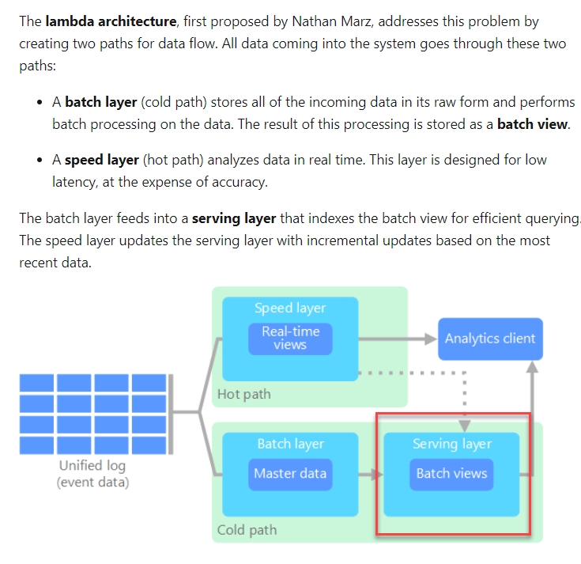

Option A is incorrect since this should be used for storing raw data.

Option B is incorrect since this should be used for ingesting data.

Option C is incorrect since this is used for analyzing data.

For more information on Big Data architectures, please visit the below URL-

* <https://docs.microsoft.com/en-us/azure/architecture/data-guide/big-data/>

### **Question 15**

Domain :Design for data security and compliance

Your company is planning on transferring data from an Azure Data Lake Storage account. The data will be transferred using Azure Data Factory. The data will then be loaded into a data warehouse in Azure Synapse using PolyBase. The data in the Azure Data Lake Storage account will be accessed via a virtual network service endpoint.

Which of the following should be used as the authentication method to access the data in the Azure Data Lake Storage account?

]A.

**Shared Access Key Authentication**

]B.

**Managed Identity Authentication**

]C.

**Account Key Authentication**

]D.

**Service Principal Authentication**

**Explanation:**

Answer – B

This is clearly mentioned in the Microsoft documentation that when you access data in an Azure Data Lake Storage account via a virtual network service endpoint, you have to use Managed Identity Authentication.

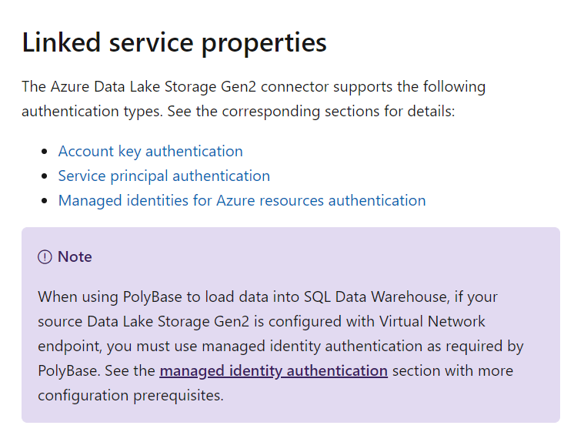

Since this is clearly mentioned in the documentation, all other options are incorrect

For more information on the Azure Data Factory connector for Azure Data Lake, please visit the below URL

* <https://docs.microsoft.com/en-us/azure/data-factory/connector-azure-data-lake-storage>

### **Question 16**

Domain :Design data processing solutions

A company is planning to build a solution that would contain the below layers.

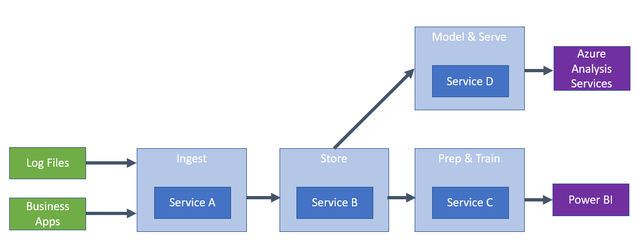

You have to decide on which services will be used for each layer.

Which of the following would you choose as the service to use Service A?

]A.

**Azure Blob Storage**

]B.

**Azure Data Factory**

]C.

**Azure Databricks**

]D.

**Azure SQL Datawarehouse**

**Explanation:**

Answer – B

Here you can use the Azure Data Factory service.

This is also given in the Microsoft documentation.

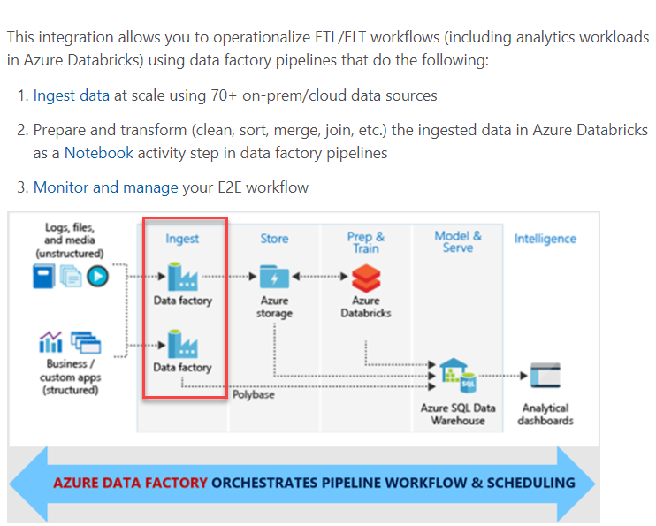

Since this is clearly given in the Microsoft blog article, all other options are incorrect.

For more information on the blog article, please visit the below URL-

* <https://azure.microsoft.com/en-us/blog/operationalize-azure-databricks-notebooks-using-data-factory/>

### **Question 17**

Domain :Design data processing solutions

A company is planning to build a solution that would contain the below layers.

You have to decide on which services will be used for each layer.

Which of the following would you choose as the service to use Service B?

]A.

**Azure Blob Storage**

]B.

**Azure Data Factory**

]C.

**Azure Databricks**

]D.

**Azure SQL Datawarehouse**

**Explanation:**

Answer – A

Here you can use the Azure Blob storage service.

This is also given in the Microsoft documentation.

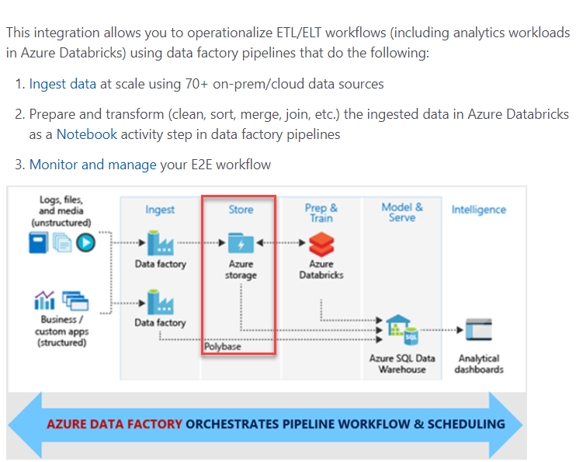

Since this is clearly given in the Microsoft blog article, all other options are incorrect.

For more information on the blog article, please visit the below URL-

* <https://azure.microsoft.com/en-us/blog/operationalize-azure-databricks-notebooks-using-data-factory/>

### **Question 18**

Domain :Design data processing solutions

A company is planning to build a solution that would contain the below layers.

You have to decide on which services will be used for each layer.

Which of the following would you choose as the service to use Service C?

]A.

**Azure Blob Storage**

]B.

**Azure Data Factory**

]C.

**Azure Databricks**

]D.

**Azure SQL Datawarehouse**

**Explanation:**

Answer – C

Here you can use the Azure Databricks service.

This is also given in the Microsoft documentation.

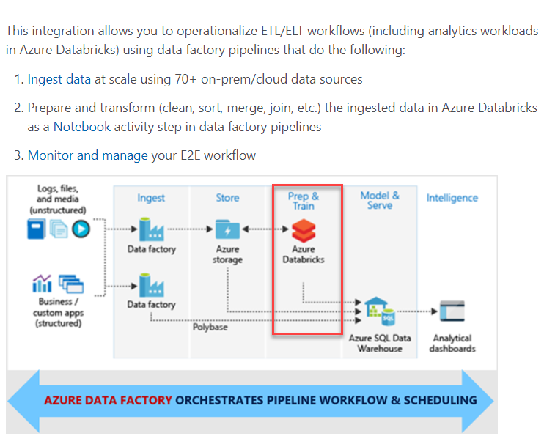

Since this is clearly given in the Microsoft blog article, all other options are incorrect.

For more information on the blog article, please visit the below URL-

* <https://azure.microsoft.com/en-us/blog/operationalize-azure-databricks-notebooks-using-data-factory/>

### **Question 19**

Domain :Design data processing solutions

A company is planning to build a solution that would contain the below layers.

You have to decide on which services will be used for each layer.

Which of the following would you choose as the service to use Service D?

]A.

**Azure Blob Storage**

]B.

**Azure Data Factory**

]C.

**Azure Databricks**

]D.

**Azure SQL Datawarehouse**

**Explanation:**

Answer – D

Here you can use the Azure SQL data warehouse service.

This is also given in the Microsoft documentation.

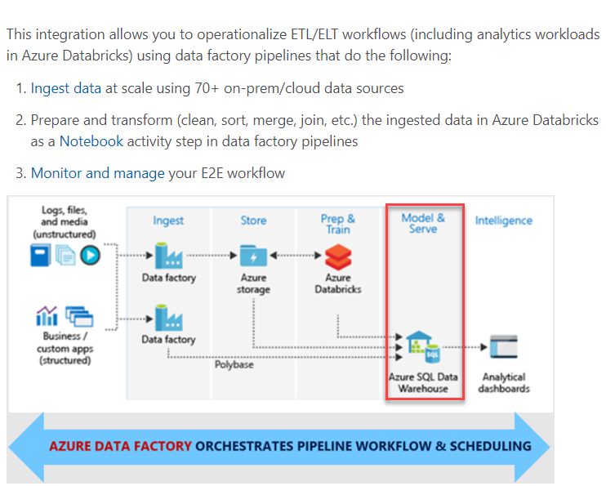

Since this is clearly given in the Microsoft blog article, all other options are incorrect.

For more information on the blog article, please visit the below URL-

* <https://azure.microsoft.com/en-us/blog/operationalize-azure-databricks-notebooks-using-data-factory/>

### **Question 20**

Domain :Design Azure data storage solutions

A company currently stores data about its customers. The different properties of the customer data are shown below.

|  |  |  |  |
| --- | --- | --- | --- |
| **Name** | **Data populated** | **Unique values** | **Distinct values** |
| **Customer ID** | 100 % | Each value is unique | 50,000 |
| **Customer Surname** | 98% | 50% of the values are unique | 32,000 |
| **Customer Given Name** | 98% | 50% of the values are unique | 25,000 |
| **Customer Birth Date** | 97% | 30% of the values are unique | 150 |
| **Customer Category** | 100% | 0% of the values are unique | 30 |

The data is going to be stored in an Azure Cosmos DB container. The queries on the data will be filtered by using the Customer Category and the Customer Surname.

Which of the following would you use as the Partition Key?

]A.

**Customer ID**

]B.

**Customer Surname**

]C.

**Customer Given Name**

]D.

**Customer Category**

**Explanation:**

Answer – D

We have to choose the partition key, which will be used as part of the queries and all the values in place. Hence, we can use the Customer Category as the partition key.

The Microsoft documentation mentions the following.

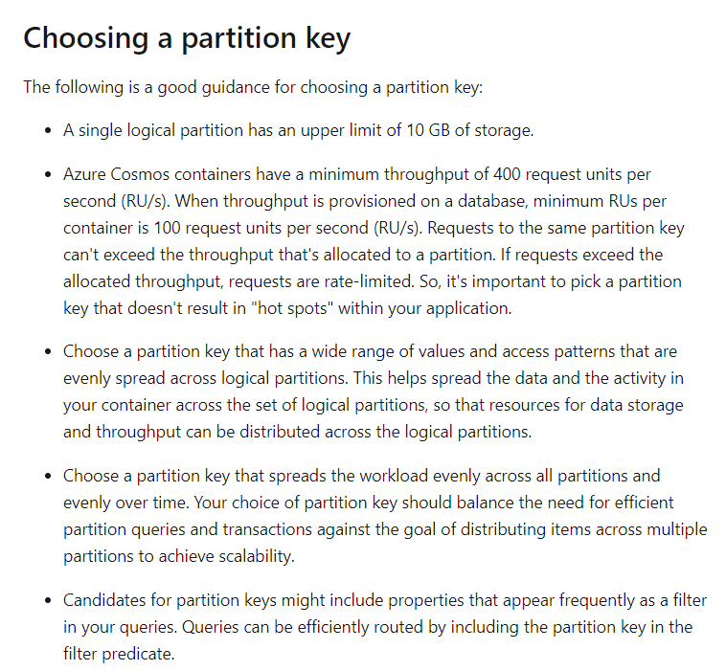

Since this is the ideal candidate for the partition key, all other options are incorrect.

For more information on Azure Cosmos DB partitioning, please visit the below URL-

* <https://docs.microsoft.com/en-us/azure/cosmos-db/partitioning-overview>

### **Question 21**

Domain :Design Azure data storage solutions

A company currently stores data about its customers. The different properties of the customer data are shown below.

|  |  |  |  |
| --- | --- | --- | --- |
| **Name** | **Data populated** | **Unique values** | **Distinct values** |
| **Customer ID** | 100 % | Each value is unique | 50,000 |
| **Customer Surname** | 98% | 50% of the values are unique | 32,000 |
| **Customer Given Name** | 98% | 50% of the values are unique | 25,000 |
| **Customer Birth Date** | 97% | 30% of the values are unique | 150 |
| **Customer Category** | 100% | 0% of the values are unique | 30 |

The data is going to be stored in an Azure Cosmos DB container. The queries on the data will be filtered by using the Customer Category and the Customer Surname.

Which of the following would you use as the Item ID?

]A.

**Customer ID**

]B.

**Customer Surname**

]C.

**Customer Given Name**

]D.

**Customer Category**

**Explanation:**

Answer – A

We have all of the values of the Customer ID and each value is unique. We can use this as the Item ID of the container.

The Microsoft documentation mentions the following.

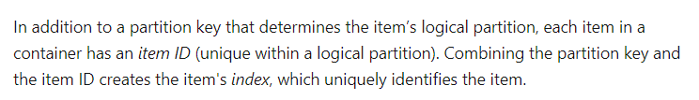

Since this is the ideal candidate for the Item ID, all other options are incorrect.

For more information on Azure Cosmos DB partitioning, please visit the below URL-

* <https://docs.microsoft.com/en-us/azure/cosmos-db/partitioning-overview>

### **Question 26**

Domain :Design Azure data storage solutions

A company wants to create multiple Cosmos DB accounts. Each account has different requirements. Below are the requirements for each account.

* Compaccount-stag – This account should be able to store log records.
* Compaccount-prod – This account should be able to store Social media mentions.

Which of the following would you use as the API for the Compaccount-stag account?

]A.

**Cassandra**

]B.

**Gremlin**

]C.

**SQL**

]D.

**Table**

**Explanation:**

Answer – C

The ideal API for this would be the SQL API. Since the data in the SQL API is stored in JSON format, this could be the ideal API for the Cosmos DB account.

Since this would be the ideal approach, all other options are incorrect.

For more information on the SQL API, please visit the below URL-

* <https://docs.microsoft.com/en-us/azure/cosmos-db/sql-query-getting-started>

### **Question 27**

Domain :Design Azure data storage solutions

A company wants to create multiple Cosmos DB accounts. Each account has different requirements. Below are the requirements for each account.

* Compaccount-stag – This account should be able to store log records.
* Compaccount-prod – This account should be able to store Social media mentions.

Which of the following would you use as the API for the Compaccount-prod account?

]A.

**Cassandra**

]B.

**Gremlin**

]C.

**SQL**

]D.

**Table**

**Explanation:**

Answer – B

The ideal API for this would be the Gremlin API.

Some of the examples given in the Microsoft documentation for the Gremlin API are given below.

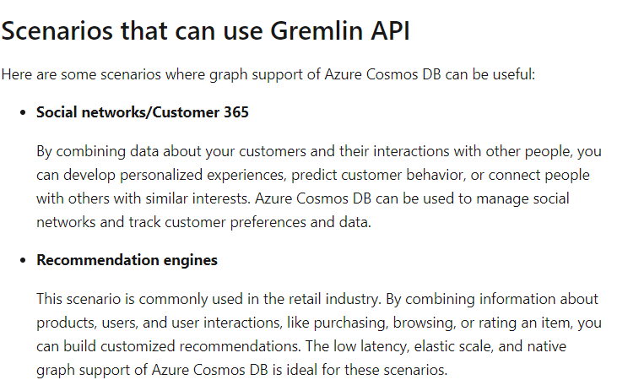

Since this is clearly mentioned in the documentation, all other options are incorrect.

For more information on the Gremlin API, please visit the below URL-

* <https://docs.microsoft.com/en-us/azure/cosmos-db/graph-introduction>

### **Question 28**

Domain :Design Azure data storage solutions

A company is designing an application that would be used to store images. They are going to be using Azure blob storage. They have the following requirements when it comes to the storage of images.

* When an image is first uploaded, it would be accessed frequently.
* After a week, the images would not be accessed frequently. But if accessed, it would need to be available within 30 seconds.
* After a year, the data would not be accessed that frequently, but it would need to be available within 5 minutes if it was accessed.
* The data storage costs must be minimized.

Which of the following would you choose as the storage tier for the images for the first week?

]A.

**Hot**

]B.

**Cool**

]C.

**Stale**

]D.

**Archive**

**Explanation:**

Answer – A

Since the images are downloaded frequently during the first week, we need to use the Hot access tier.

The Microsoft documentation mentions the following.

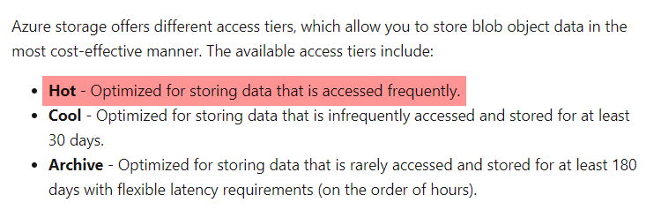

Since this is clearly mentioned in the documentation, all other options are incorrect.

For more information on Azure storage access tiers, please visit the below URL-

* <https://docs.microsoft.com/en-us/azure/storage/blobs/storage-blob-storage-tiers>

### **Question 29**

Domain :Design Azure data storage solutions

A company is designing an application that would be used to store images. They are going to be using Azure blob storage. They have the following requirements when it comes to the storage of images.

* When an image is first uploaded, it would be accessed frequently.
* After a week, the images would not be accessed frequently. But if accessed, it would need to be available within 30 seconds.
* After a year, the data would not be accessed that frequently, but it would need to be available within 5 minutes if it was accessed.
* The data storage costs must be minimized.

Which of the following would you choose as the storage tier for the images after a month?

]A.

**Hot**

]B.

**Cool**

]C.

**Stale**

]D.

**Archive**

**Explanation:**

Answer – B

Since the images won’t be downloaded that frequently after a month, the most cost-effective tier is the Cool tier. The Archive tier would not allow the images to be downloaded in 30 seconds, so this can’t be used as the storage tier.

The Microsoft documentation mentions the following.

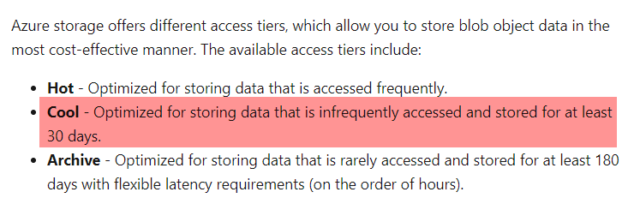

Since this is clearly mentioned in the documentation, all other options are incorrect.

For more information on Azure storage access tiers, please visit the below URL-

* <https://docs.microsoft.com/en-us/azure/storage/blobs/storage-blob-storage-tiers>

### **Question 30**

Domain :Design Azure data storage solutions

A company is designing an application that would be used to store images. They are going to be using Azure blob storage. They have the following requirements when it comes to the storage of images.

* When an image is first uploaded it would be accessed frequently.
* After a week, the images would not be accessed frequently. But if accessed, it would need to be available within 30 seconds.
* After a year the data would not be accessed that frequently, but if it was accessed, it would need to be available within 5 minutes.
* The data storage costs must be minimized.

Which of the following would you choose as the storage tier for the images after a year?

]A.

**Hot**

]B.

**Cool**

]C.

**Stale**

]D.

**Archive**

**Explanation:**

Answer – D

The images won’t be downloaded that frequently after a month. You can take 5 minutes for the image to be available. The most cost-effective storage tier is the Archive storage tier.

The Microsoft documentation mentions the following.

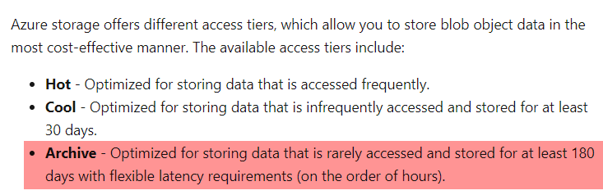

Since this is clearly mentioned in the documentation, all other options are incorrect.

For more information on Azure storage access tiers, please visit the below URL-

* <https://docs.microsoft.com/en-us/azure/storage/blobs/storage-blob-storage-tiers>

### **Question 31**

Domain :Design for data security and compliance

Your company wants to design a system that would consist of an Azure virtual machine and an Azure SQL database. The database would not have any Internet connectivity. You need to implement a solution that would ensure that the virtual machine could access the database. Which of the following would you implement for this requirement?

]A.

**Add a virtual network service endpoint.**

]B.

**Add an Application gateway.**

]C.

**Add a virtual network gateway.**

]D.

**Add an Azure Load balancer.**

**Explanation:**

Answer – A

You can make use of Virtual Network service endpoints to expose Azure SQL databases to virtual networks.

This is also mentioned in a Microsoft blog article.

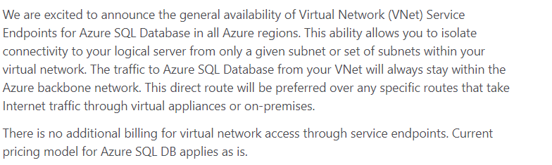

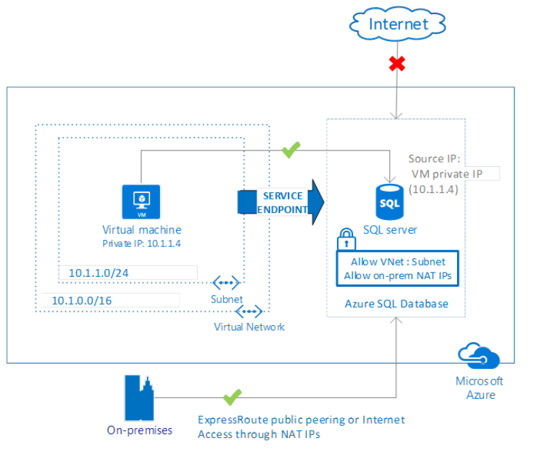

Since this is clearly mentioned in the documentation, all other options are incorrect.

For more information on the blog article, please visit the below URL-

* <https://azure.microsoft.com/en-us/blog/vnet-service-endpoints-for-azure-sql-database-now-generally-available>

### **Question 32**

Domain :Design Azure data storage solutions

A company wants to design a data store that would be used to store telemetry data. Which of the following could be used as the underlying data store?

]A.

**Azure Databricks**

]B.

**Azure SQL data warehouse**

]C.

**Azure Cosmos DB**

]D.

**Azure Functions.**

**Explanation:**

Answer – C

The ideal choice is Cosmos DB. This is also given as an example in the Microsoft documentation.

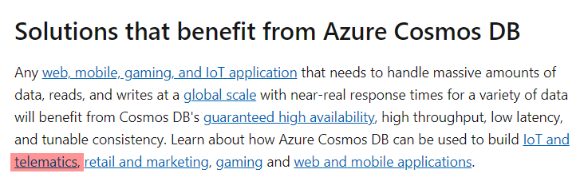

Since this is clearly mentioned in the documentation, all other options are incorrect.

For more information on Azure Cosmos DB, please visit the below URL-

* <https://docs.microsoft.com/en-us/azure/cosmos-db/introduction>

### **Question 33**

Domain :Design Azure data storage solutions

Your company is planning to use the Azure SQL database and Azure storage accounts for an application. The application would extract data, convert the data to text documents and store them in the storage account. The text documents must be accessible from an SMB network share. Which of the following would you use as the underlying service type for the Azure storage account?

]A.

**Queue**

]B.

**Files**

]C.

**Blob**

]D.

**Table**

**Explanation:**

Answer – B

The File service allows one to access files via the SMB protocol.

The Microsoft documentation mentions the following.

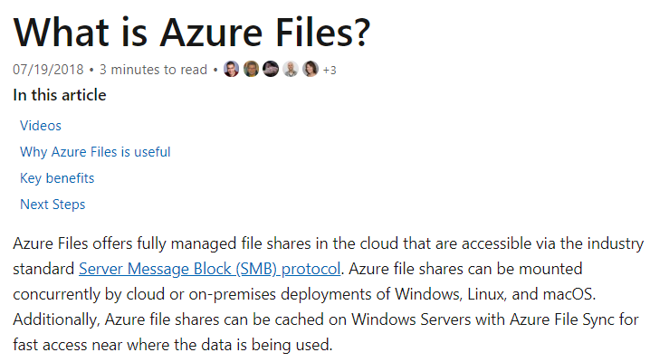

Since this is clearly mentioned in the documentation, all other options are incorrect.

For more information on the file service, please visit the below URL-

* <https://docs.microsoft.com/en-us/azure/storage/files/storage-files-introduction>

### **Question 34**

Domain :Design Azure data storage solutions

A company has an on-premise Microsoft SQL Server. They want to migrate the database to Azure SQL Databases.

Which of the following would they use as the file type for exporting the on-premise database?

]A.

**BACPAC**

]B.

**DAC**

]C.

**VHD**

]D.

**VHDX**

**Explanation:**

Answer – A

To export the database, you need to create a BACPAC file.

The Microsoft documentation mentions the following.

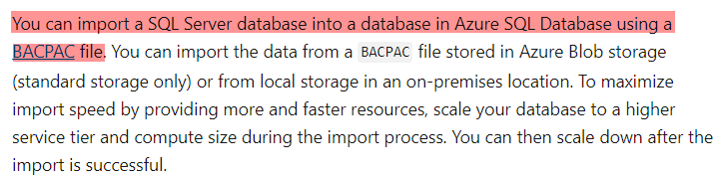

Since this is clearly mentioned in the documentation, all other options are incorrect.

For more information on exporting a SQL Server database, please visit the below URL-

* <https://docs.microsoft.com/en-us/azure/sql-database/sql-database-import?tabs=azure-powershell>

### **Question 35**

Domain :Design Azure data storage solutions

A company has an on-premise Microsoft SQL Server. They want to migrate the database to Azure SQL Databases.

Which of the following should be the underlying storage type for the exported data?

]A.

**Blob**

]B.

**Disk**

]C.

**File**

]D.

**Queue**

**Explanation:**

Answer – A

The BACPAC file must be stored in Azure Blob storage.

The Microsoft documentation mentions the following.

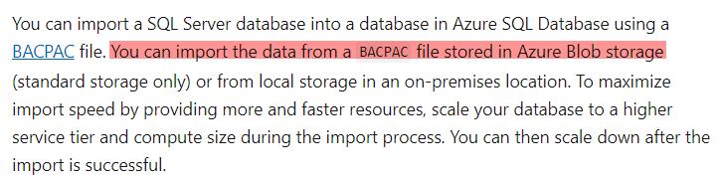

Since this is clearly mentioned in the documentation, all other options are incorrect.

For more information on exporting a SQL Server database, please visit the below URL-

* <https://docs.microsoft.com/en-us/azure/sql-database/sql-database-import?tabs=azure-powershell>

### **Question 36**

Domain :Design data processing solutions

Your company currently stores data in different types of Azure cloud-based databases. The company wants to consolidate the data into a single relational database. The data would be ingested at a set time of the day. Which of the following could be a recommendation to implement this requirement?

]A.

**SQL Server Migration Assistant**

]B.

**SQL Data Sync**

]C.

**Azure Data Factory**

]D.

**Azure Database Migration Service**

**Explanation:**

Answer – C

Azure Data Factory can be used to transfer and transform data from multiple sources into a destination. Schedules can also be set for the data transfer.

The Microsoft documentation mentions the following.

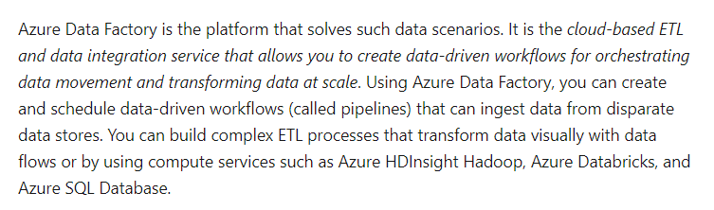

Options A and D are incorrect since this is a tool used to automate the migration of data on a database from another single database.

Option B is incorrect since this is just used to sync data between databases.

For more information on Azure Data Factory, please visit the below URL-

* <https://docs.microsoft.com/en-us/azure/data-factory/introduction>

### **Question 37**

Domain :Design data processing solutions

A company wants to implement an Azure Databricks cluster. The cluster configuration needs to meet the following requirements.

* Multiple users must be able to use the cluster.
* Overall costs must be reduced.
* Query latency should be minimized.

Which of the following should be implemented as the cluster configuration for this requirement?

]A.

**Standard cluster with Autoscaling enabled**

]B.

**High Concurrency cluster with Autoscaling enabled**

]C.

**Standard cluster with Auto Termination enabled**

]D.

**High Concurrency cluster with Auto Termination enabled**

**Explanation:**

Answer – B

For multiple users, you should use a High Concurrency cluster.

The Microsoft documentation mentions the following.

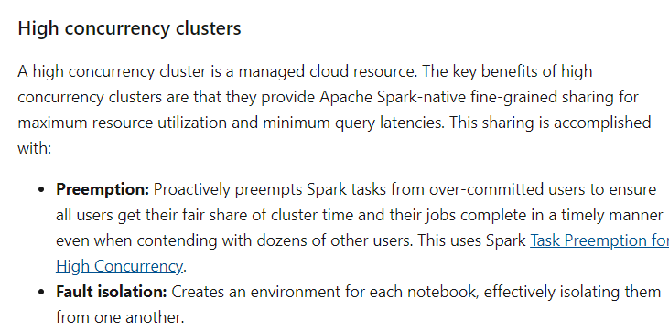

Options A and C are incorrect since High Concurrency clusters should be used when multiple users are going to use the clusters.

Option D is incorrect since Auto Termination is not possible with High Concurrency clusters.

For more information on Azure Databricks cluster configuration, please visit the below URL-

* <https://docs.microsoft.com/en-us/azure/databricks/clusters/configure>

### **Question 38**

Domain :Design data processing solutions

A company wants to migrate an on-premise MySQL database that is 800 GB in size. The database needs to be migrated to Azure database for MySQL. The migration must be performed in such a way that it would minimize interruptions to applications that use the database. Which of the following would you use to fulfill this requirement?

]A.

**Azure Database Migration Service**

]B.

**Import and Export**

]C.

**Azure Data Sync**

]D.

**MySQL WorkBench**

**Explanation:**

Answer – A

The Azure Database Migration Service can be used to perform the migration.

The Microsoft documentation mentions the following.

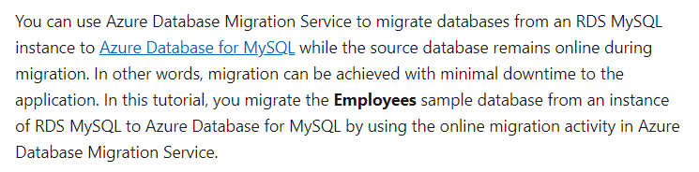

Since this is clearly given in the Microsoft documentation, all other options are incorrect.

For more information on using the Database Migration Service for MySQL, please visit the below URL-

* <https://docs.microsoft.com/en-us/azure/dms/tutorial-rds-mysql-server-azure-db-for-mysql-online>

### **Question 39**

Domain :Design Azure data storage solutions

A company wants to use the Azure SQL database service. Business apps will be accessing the database. They want to create an Azure SQL database managed instance. They want to ensure that the database can automatically recover from a full or partial loss of the Azure SQL database service in the primary region. Which of the following can help achieve this requirement?

]A.

**Failover-groups**

]B.

**Azure SQL Data Sync**

]C.

**SQL Replication**

]D.

**Active geo-replication**

**Explanation:**

Answer – A

For managed instances, you have to use failover groups.

The Microsoft documentation mentions the following.

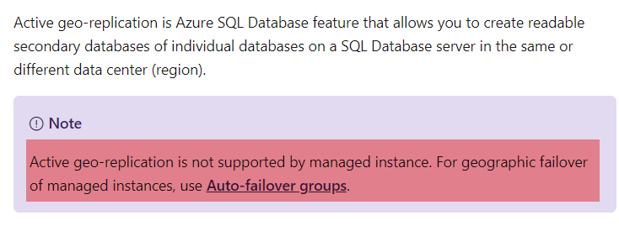

Since this is clearly given in the Microsoft documentation, all other options are incorrect.

For more information on auto-failover groups, please visit the below URL-

* <https://docs.microsoft.com/en-us/azure/sql-database/sql-database-auto-failover-group?tabs=azure-powershell>

### **Question 40**

Domain :Design Azure data storage solutions

A company is making use of Azure stream analytics for a solution. They want to ensure that the solution remains available even in the event of Azure service updates. Which of the following should they implement for this requirement? Choose 2 answers from the options given below.

A.

**Deploy an Azure Stream Analytics job to one region that is part of a paired region.**

B.

**Deploy an Azure Stream Analytics job to each region of a paired region.**

C.

**Monitor jobs in both regions for failure.**

D.

**Monitor the job in the primary region for failure.**

**Explanation:**

Answer – B and C

You need to deploy an Azure Stream Analytics job to each region of a paired region and then monitor both jobs.

The Microsoft documentation mentions the following.

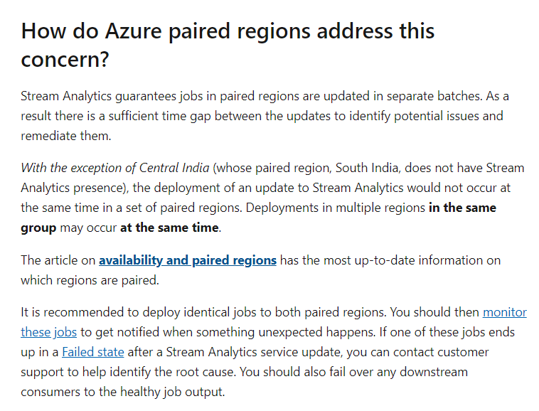

Since this is clearly given in the Microsoft documentation, all other options are incorrect.

For more information on Azure Analytics job reliability, please visit the below URL-

* <https://docs.microsoft.com/en-us/azure/stream-analytics/stream-analytics-job-reliability>

### **Question 41**

Domain :Design data processing solutions

A company needs to design a solution that would require to perform analytics and visualization on a large data set. The solution should use notebooks, automate clusters and provide the ability to use Power BI to visualize the data. Which of the following would you use for this requirement?

]A.

**Azure Batch**

]B.

**Azure Stream Analytics**

]C.

**Azure Databricks**

]D.

**Azure HDInsight**

**Explanation:**

Answer – C

With Azure Databricks, you can create clusters and notebooks.

The Microsoft documentation mentions the following.

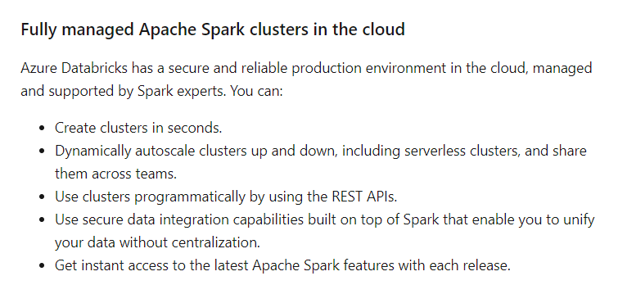

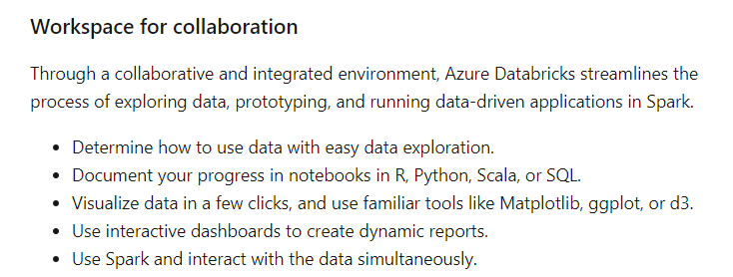

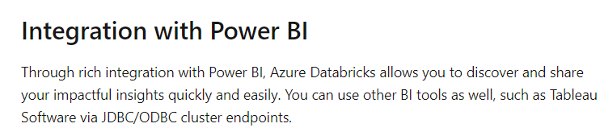

Since this service satisfies the requirements, all other options are incorrect.

For more information on Azure Databricks, please visit the below URL-

* <https://docs.microsoft.com/en-us/azure/azure-databricks/what-is-azure-databricks>

### **Question 42**

Domain :Design Azure data storage solutions

[**View Case Study**](javascript:;)

**Overview**

A company currently has the following virtual machines in their on-premise data centre

|  |  |  |  |  |
| --- | --- | --- | --- | --- |
| **Name** | **Role** | **Database Size** | **Type** | **Destination on Azure** |
| **comp_sql1** | Microsoft SQL Server | 2 TB | Hyper-V | Azure SQL Database |
| **comp_sql2** | Microsoft SQL Server | 2 TB | Hyper-V | Azure SQL Database |
| **comp_sql3** | Microsoft SQL Server | 90 GB | Hyper-V | Azure Virtual Machine |
| **comp_sap1** | SAP | 1 TB | VMWare | On-premise |
| **comp_sap2** | SAP | 1 TB | VMWare | On-premise |

**Requirements**

The company wants to migrate the SQL server workloads to Azure. Below are the key requirements

* The server comp_sql3 requires an initial IOPS of 35000
* The servers comp_sql1 and comp_sql2 must use the vCore model and should also use replicas. These servers must support an IOPS of 8000.
* The compute and storage resources must be scaled independently
* The data from the SQL Servers must use zone redundant storage
* The current applications running on the on-premise servers must be able to interact with the databases on Azure.
* A regional disaster recover strategy must also be in place
* The database backups must be retained for 7 years
* The server comp_sql1 contains sales data. Data analysis must be performed on this data.  A solution must in place which would read data from the database, perform ETL and then output the results to Power BI. The solution must use managed clusters to minimize costs.
* The analytics solution which would be in place for the sales data must be available even in the event of a regional outage.
* All employee PII data must be encrypted in rest and in transit
* Keys must be in place using hardware security modules
* The server comp_sql3 must not be able to communicate over the default ports
* Data engineers must be able to set the compute resources for the Data warehouse to 250 DWUs
* The server costs for comp_sql2 must be reduced when it is not being used during non-peak hours

Which of the following would you use as the disk type for server comp_sql3 when it is migrated to Azure?

]A.

**Ultra Disk**

]B.

**Premium SSD**

]C.

**Standard SSD**

]D.

**Standard HDD**

**Explanation:**

Answer – A

There is a requirement to support an IOPS of 35,000. We need to use an Ultra disk, which would fulfill this requirement.

The Microsoft documentation mentions the following.

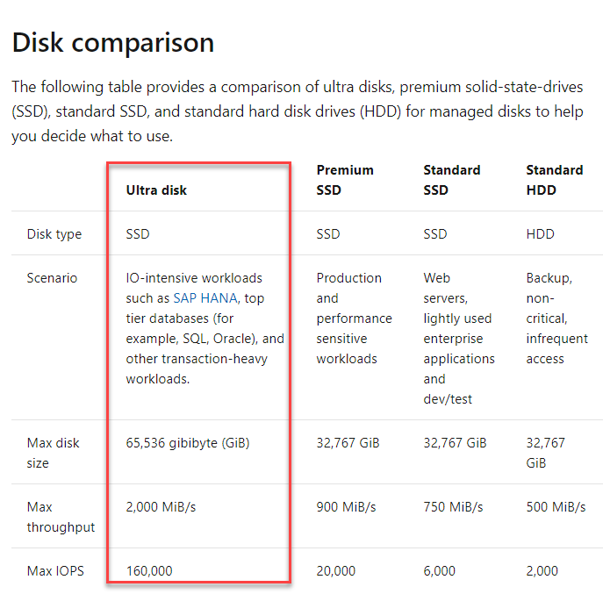

Since this is clear from the documentation, all other options are incorrect.

For more information on disk types, visit the below URL-

* <https://docs.microsoft.com/en-us/azure/virtual-machines/windows/disks-types>

### **Question 43**

Domain :Design Azure data storage solutions

[**View Case Study**](javascript:;)

**Overview**

A company currently has the following virtual machines in their on-premise data centre

|  |  |  |  |  |
| --- | --- | --- | --- | --- |
| **Name** | **Role** | **Database Size** | **Type** | **Destination on Azure** |
| **comp_sql1** | Microsoft SQL Server | 2 TB | Hyper-V | Azure SQL Database |
| **comp_sql2** | Microsoft SQL Server | 2 TB | Hyper-V | Azure SQL Database |
| **comp_sql3** | Microsoft SQL Server | 90 GB | Hyper-V | Azure Virtual Machine |
| **comp_sap1** | SAP | 1 TB | VMWare | On-premise |
| **comp_sap2** | SAP | 1 TB | VMWare | On-premise |

**Requirements**

The company wants to migrate the SQL server workloads to Azure. Below are the key requirements

* The server comp_sql3 requires an initial IOPS of 35000
* The servers comp_sql1 and comp_sql2 must use the vCore model and should also use replicas. These servers must support an IOPS of 8000.
* The compute and storage resources must be scaled independently
* The data from the SQL Servers must use zone redundant storage
* The current applications running on the on-premise servers must be able to interact with the databases on Azure.
* A regional disaster recover strategy must also be in place
* The database backups must be retained for 7 years
* The server comp_sql1 contains sales data. Data analysis must be performed on this data.  A solution must in place which would read data from the database, perform ETL and then output the results to Power BI. The solution must use managed clusters to minimize costs.
* The analytics solution which would be in place for the sales data must be available even in the event of a regional outage.
* All employee PII data must be encrypted in rest and in transit
* Keys must be in place using hardware security modules
* The server comp_sql3 must not be able to communicate over the default ports
* Data engineers must be able to set the compute resources for the Data warehouse to 250 DWUs
* The server costs for comp_sql2 must be reduced when it is not being used during non-peak hours

Which of the following would you choose as the database service tier?

]A.

**General Purpose**

]B.

**Basic**

]C.

**Standard**

]D.

**Premium**

**Explanation:**

Answer – D

Since the databases are 2 TB in size, we need to use the Premium service tier which fulfills this requirement.

The Microsoft documentation mentions the following.

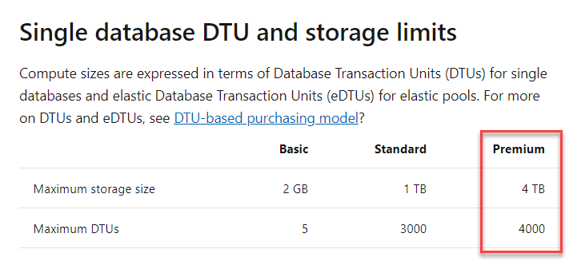

Since this is clear from the documentation, all other options are incorrect.

For more information on Azure SQL database tiers, visit the below URL-

* <https://docs.microsoft.com/en-us/azure/sql-database/sql-database-service-tiers-dtu>

### **Question 44**

Domain :Design for data security and compliance

[**View Case Study**](javascript:;)

**Overview**

A company currently has the following virtual machines in their on-premise data centre

|  |  |  |  |  |
| --- | --- | --- | --- | --- |
| **Name** | **Role** | **Database Size** | **Type** | **Destination on Azure** |
| **comp_sql1** | Microsoft SQL Server | 2 TB | Hyper-V | Azure SQL Database |
| **comp_sql2** | Microsoft SQL Server | 2 TB | Hyper-V | Azure SQL Database |
| **comp_sql3** | Microsoft SQL Server | 90 GB | Hyper-V | Azure Virtual Machine |
| **comp_sap1** | SAP | 1 TB | VMWare | On-premise |
| **comp_sap2** | SAP | 1 TB | VMWare | On-premise |

**Requirements**

The company wants to migrate the SQL server workloads to Azure. Below are the key requirements

* The server comp_sql3 requires an initial IOPS of 35000
* The servers comp_sql1 and comp_sql2 must use the vCore model and should also use replicas. These servers must support an IOPS of 8000.
* The compute and storage resources must be scaled independently
* The data from the SQL Servers must use zone redundant storage
* The current applications running on the on-premise servers must be able to interact with the databases on Azure.
* A regional disaster recover strategy must also be in place
* The database backups must be retained for 7 years
* The server comp_sql1 contains sales data. Data analysis must be performed on this data.  A solution must in place which would read data from the database, perform ETL and then output the results to Power BI. The solution must use managed clusters to minimize costs.
* The analytics solution which would be in place for the sales data must be available even in the event of a regional outage.
* All employee PII data must be encrypted in rest and in transit
* Keys must be in place using hardware security modules
* The server comp_sql3 must not be able to communicate over the default ports
* Data engineers must be able to set the compute resources for the Data warehouse to 250 DWUs
* The server costs for comp_sql2 must be reduced when it is not being used during non-peak hours

You have to ensure that data can be accessed from the on-premise network for the Azure SQL Databases. Which of the following would you use as the tool to access the data?

]A.

**SQL Server Configuration Manager**

]B.

**Azure Storage Explorer**

]C.

**Azure Portal**

]D.

**SQL Server Management Studio**

**Explanation:**

Answer – D

You can use SQL Server Management Studio to access the data.

The Microsoft documentation mentions the following.

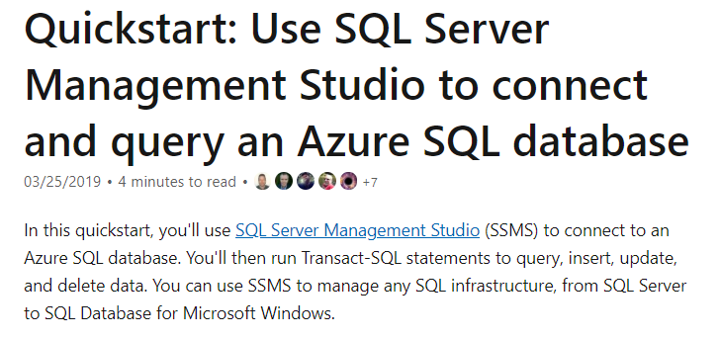

Since this is clear from the documentation, all other options are incorrect.

For more information on accessing Azure SQL databases with SQL Server Management Studio, visit the below URL-

* <https://docs.microsoft.com/en-us/azure/sql-database/sql-database-connect-query-ssms>

### **Question 45**

Domain :Design for data security and compliance

[**View Case Study**](javascript:;)

**Overview**

A company currently has the following virtual machines in their on-premise data centre

|  |  |  |  |  |
| --- | --- | --- | --- | --- |
| **Name** | **Role** | **Database Size** | **Type** | **Destination on Azure** |
| **comp_sql1** | Microsoft SQL Server | 2 TB | Hyper-V | Azure SQL Database |
| **comp_sql2** | Microsoft SQL Server | 2 TB | Hyper-V | Azure SQL Database |
| **comp_sql3** | Microsoft SQL Server | 90 GB | Hyper-V | Azure Virtual Machine |
| **comp_sap1** | SAP | 1 TB | VMWare | On-premise |
| **comp_sap2** | SAP | 1 TB | VMWare | On-premise |

**Requirements**

The company wants to migrate the SQL server workloads to Azure. Below are the key requirements

* The server comp_sql3 requires an initial IOPS of 35000
* The servers comp_sql1 and comp_sql2 must use the vCore model and should also use replicas. These servers must support an IOPS of 8000.
* The compute and storage resources must be scaled independently
* The data from the SQL Servers must use zone redundant storage
* The current applications running on the on-premise servers must be able to interact with the databases on Azure.
* A regional disaster recover strategy must also be in place
* The database backups must be retained for 7 years
* The server comp_sql1 contains sales data. Data analysis must be performed on this data.  A solution must in place which would read data from the database, perform ETL and then output the results to Power BI. The solution must use managed clusters to minimize costs.
* The analytics solution which would be in place for the sales data must be available even in the event of a regional outage.
* All employee PII data must be encrypted in rest and in transit
* Keys must be in place using hardware security modules
* The server comp_sql3 must not be able to communicate over the default ports
* Data engineers must be able to set the compute resources for the Data warehouse to 250 DWUs
* The server costs for comp_sql2 must be reduced when it is not being used during non-peak hours

You have to ensure that data can be accessed from the on-premise network for the Azure SQL Databases. Which of the following would you use as the port number to connect to the database?

]A.

**80**

]B.

**8080**

]C.

**1433**

]D.

**3306**

**Explanation:**

Answer – C

The Azure SQL database listens on port 1433.

The Microsoft documentation mentions the following.

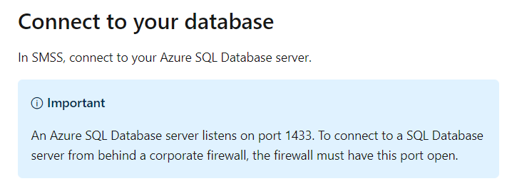

Since this is clear from the documentation, all other options are incorrect.

For more information on accessing Azure SQL databases with SQL Server Management Studio, visit the below URL-

* <https://docs.microsoft.com/en-us/azure/sql-database/sql-database-connect-query-ssms>

### **Question 46**

Domain :Design for data security and compliance

[**View Case Study**](javascript:;)

**Overview**

A company currently has the following virtual machines in their on-premise data centre

|  |  |  |  |  |
| --- | --- | --- | --- | --- |
| **Name** | **Role** | **Database Size** | **Type** | **Destination on Azure** |
| **comp_sql1** | Microsoft SQL Server | 2 TB | Hyper-V | Azure SQL Database |
| **comp_sql2** | Microsoft SQL Server | 2 TB | Hyper-V | Azure SQL Database |
| **comp_sql3** | Microsoft SQL Server | 90 GB | Hyper-V | Azure Virtual Machine |
| **comp_sap1** | SAP | 1 TB | VMWare | On-premise |
| **comp_sap2** | SAP | 1 TB | VMWare | On-premise |

**Requirements**

The company wants to migrate the SQL server workloads to Azure. Below are the key requirements

* The server comp_sql3 requires an initial IOPS of 35000
* The servers comp_sql1 and comp_sql2 must use the vCore model and should also use replicas. These servers must support an IOPS of 8000.
* The compute and storage resources must be scaled independently
* The data from the SQL Servers must use zone redundant storage
* The current applications running on the on-premise servers must be able to interact with the databases on Azure.
* A regional disaster recover strategy must also be in place
* The database backups must be retained for 7 years
* The server comp_sql1 contains sales data. Data analysis must be performed on this data.  A solution must in place which would read data from the database, perform ETL and then output the results to Power BI. The solution must use managed clusters to minimize costs.
* The analytics solution which would be in place for the sales data must be available even in the event of a regional outage.
* All employee PII data must be encrypted in rest and in transit
* Keys must be in place using hardware security modules
* The server comp_sql3 must not be able to communicate over the default ports
* Data engineers must be able to set the compute resources for the Data warehouse to 250 DWUs
* The server costs for comp_sql2 must be reduced when it is not being used during non-peak hours

The company wants to ensure that data is encrypted when it is stored in the Azure SQL database. Which of the following could be used for this requirement?

]A.

**Azure Disk Encryption**

]B.

**Service Encryption**

]C.

**Transparent Data Encryption**

]D.

**Azure Key Vault**

**Explanation:**

Answer – C

You can make use of Transparent Data Encryption to encrypt the data at rest.

The Microsoft documentation mentions the following.

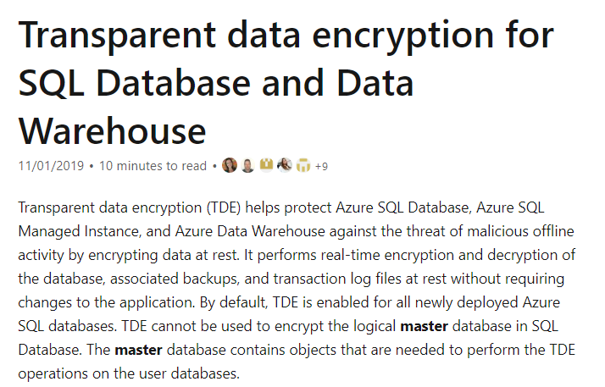

Since this is clear from the documentation, all other options are incorrect.

For more information on transparent data encryption, visit the below URL-

* <https://docs.microsoft.com/en-us/azure/sql-database/transparent-data-encryption-azure-sql?tabs=azure-portal>

### **Question 47**

Domain :Design for data security and compliance

[**View Case Study**](javascript:;)

**Overview**

A company currently has the following virtual machines in their on-premise data centre

|  |  |  |  |  |
| --- | --- | --- | --- | --- |
| **Name** | **Role** | **Database Size** | **Type** | **Destination on Azure** |
| **comp_sql1** | Microsoft SQL Server | 2 TB | Hyper-V | Azure SQL Database |
| **comp_sql2** | Microsoft SQL Server | 2 TB | Hyper-V | Azure SQL Database |
| **comp_sql3** | Microsoft SQL Server | 90 GB | Hyper-V | Azure Virtual Machine |
| **comp_sap1** | SAP | 1 TB | VMWare | On-premise |
| **comp_sap2** | SAP | 1 TB | VMWare | On-premise |

**Requirements**

The company wants to migrate the SQL server workloads to Azure. Below are the key requirements

* The server comp_sql3 requires an initial IOPS of 35000
* The servers comp_sql1 and comp_sql2 must use the vCore model and should also use replicas. These servers must support an IOPS of 8000.
* The compute and storage resources must be scaled independently
* The data from the SQL Servers must use zone redundant storage
* The current applications running on the on-premise servers must be able to interact with the databases on Azure.
* A regional disaster recover strategy must also be in place
* The database backups must be retained for 7 years
* The server comp_sql1 contains sales data. Data analysis must be performed on this data.  A solution must in place which would read data from the database, perform ETL and then output the results to Power BI. The solution must use managed clusters to minimize costs.
* The analytics solution which would be in place for the sales data must be available even in the event of a regional outage.
* All employee PII data must be encrypted in rest and in transit
* Keys must be in place using hardware security modules
* The server comp_sql3 must not be able to communicate over the default ports
* Data engineers must be able to set the compute resources for the Data warehouse to 250 DWUs
* The server costs for comp_sql2 must be reduced when it is not being used during non-peak hours

One of the databases is going to store sensitive data. You have to implement a solution that would be used to identify the sensitive data and monitor access to the data. Which of the following would you implement for this requirement? Choose 3 answers from the options given below.

A.

**Make use of Data Discovery and Classification.**

B.

**Implement Transparent Data Encryption.**

C.

**Enable auditing for the database.**

D.

**Run a vulnerability assessment.**

**Explanation:**

Answer – A, C and D

You can classify your data.

The Microsoft documentation mentions the following.

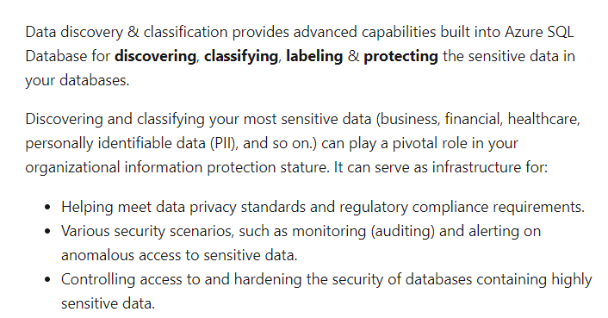

You can enable auditing for sensitive data.

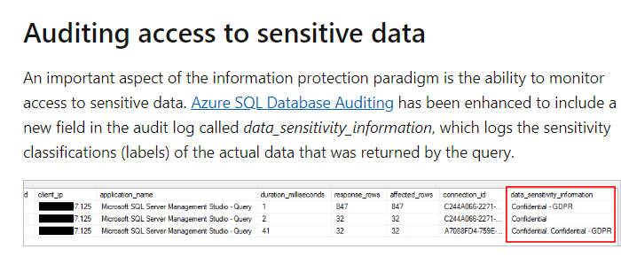

You can also run a vulnerability assessment.

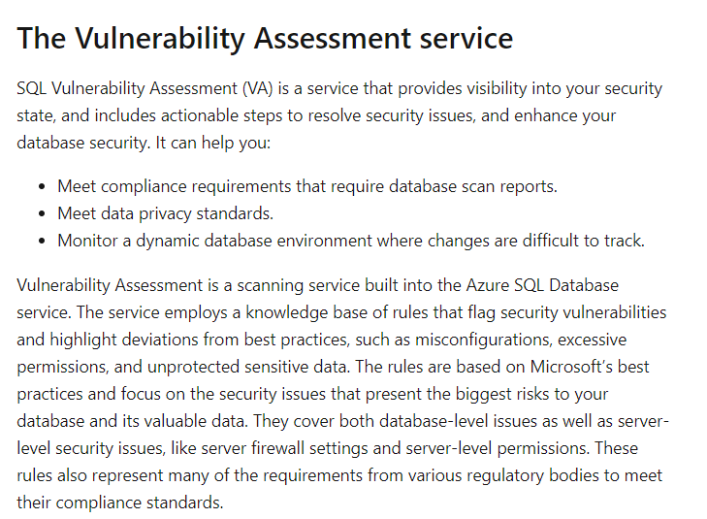

Option B is incorrect since this is used for encrypting data.

For more information on data discovery and vulnerability assessment, visit the below URL-

* <https://docs.microsoft.com/en-us/azure/sql-database/sql-vulnerability-assessment>
* <https://docs.microsoft.com/en-us/azure/sql-database/sql-database-data-discovery-and-classification?tabs=azure-t-sql>

### **Question 48**

Domain :Design for data security and compliance

[**View Case Study**](javascript:;)

**Overview**

A company currently has the following virtual machines in their on-premise data centre

|  |  |  |  |  |
| --- | --- | --- | --- | --- |
| **Name** | **Role** | **Database Size** | **Type** | **Destination on Azure** |
| **comp_sql1** | Microsoft SQL Server | 2 TB | Hyper-V | Azure SQL Database |
| **comp_sql2** | Microsoft SQL Server | 2 TB | Hyper-V | Azure SQL Database |
| **comp_sql3** | Microsoft SQL Server | 90 GB | Hyper-V | Azure Virtual Machine |
| **comp_sap1** | SAP | 1 TB | VMWare | On-premise |
| **comp_sap2** | SAP | 1 TB | VMWare | On-premise |

**Requirements**

The company wants to migrate the SQL server workloads to Azure. Below are the key requirements

* The server comp_sql3 requires an initial IOPS of 35000
* The servers comp_sql1 and comp_sql2 must use the vCore model and should also use replicas. These servers must support an IOPS of 8000.
* The compute and storage resources must be scaled independently
* The data from the SQL Servers must use zone redundant storage
* The current applications running on the on-premise servers must be able to interact with the databases on Azure.
* A regional disaster recover strategy must also be in place
* The database backups must be retained for 7 years
* The server comp_sql1 contains sales data. Data analysis must be performed on this data.  A solution must in place which would read data from the database, perform ETL and then output the results to Power BI. The solution must use managed clusters to minimize costs.
* The analytics solution which would be in place for the sales data must be available even in the event of a regional outage.
* All employee PII data must be encrypted in rest and in transit
* Keys must be in place using hardware security modules
* The server comp_sql3 must not be able to communicate over the default ports
* Data engineers must be able to set the compute resources for the Data warehouse to 250 DWUs
* The server costs for comp_sql2 must be reduced when it is not being used during non-peak hours

You have to ensure that a backup strategy is present for the serve comp_sql1 and comp_sql2. Which of the following would you implement?

]A.

**Geo-redundancy**

]B.

**Auto-failover groups**

]C.

**Long term retention**

]D.

**Disk backup**

**Explanation:**

Answer – C

Since the data needs to be retained for years, you need to use long term retention.

The Microsoft documentation mentions the following.

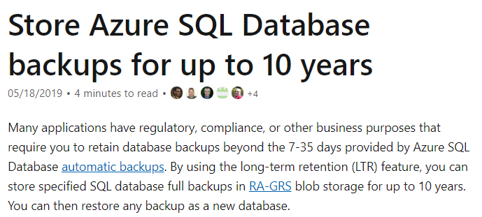

Since this is clear from the documentation, all other options are incorrect.

For more information on long term retention, visit the below URL-

* <https://docs.microsoft.com/en-us/azure/sql-database/sql-database-long-term-retention>

### **Question 49**

Domain :Design for data security and compliance

[**View Case Study**](javascript:;)

**Overview**

A company currently has the following virtual machines in their on-premise data centre

|  |  |  |  |  |
| --- | --- | --- | --- | --- |
| **Name** | **Role** | **Database Size** | **Type** | **Destination on Azure** |
| **comp_sql1** | Microsoft SQL Server | 2 TB | Hyper-V | Azure SQL Database |
| **comp_sql2** | Microsoft SQL Server | 2 TB | Hyper-V | Azure SQL Database |
| **comp_sql3** | Microsoft SQL Server | 90 GB | Hyper-V | Azure Virtual Machine |
| **comp_sap1** | SAP | 1 TB | VMWare | On-premise |
| **comp_sap2** | SAP | 1 TB | VMWare | On-premise |

**Requirements**

The company wants to migrate the SQL server workloads to Azure. Below are the key requirements

* The server comp_sql3 requires an initial IOPS of 35000
* The servers comp_sql1 and comp_sql2 must use the vCore model and should also use replicas. These servers must support an IOPS of 8000.
* The compute and storage resources must be scaled independently
* The data from the SQL Servers must use zone redundant storage
* The current applications running on the on-premise servers must be able to interact with the databases on Azure.
* A regional disaster recover strategy must also be in place
* The database backups must be retained for 7 years
* The server comp_sql1 contains sales data. Data analysis must be performed on this data.  A solution must in place which would read data from the database, perform ETL and then output the results to Power BI. The solution must use managed clusters to minimize costs.
* The analytics solution which would be in place for the sales data must be available even in the event of a regional outage.
* All employee PII data must be encrypted in rest and in transit
* Keys must be in place using hardware security modules
* The server comp_sql3 must not be able to communicate over the default ports
* Data engineers must be able to set the compute resources for the Data warehouse to 250 DWUs
* The server costs for comp_sql2 must be reduced when it is not being used during non-peak hours

You need to implement disaster recovery for the data analysis solution. Which of the following would you implement for this requirement? Choose 3 answers from the options given below.

A.

**Ensure to create multiple Azure Databricks workspaces in the same region.**

B.

**Ensure to create multiple Azure Databricks workspaces in different region.**

C.

**Ensure to use zone redundant storage.**

D.

**Ensure to use geo-redundant storage.**

E.

**Migrate the users, notebooks and cluster configuration from one region to another.**

F.

**Migrate the users, notebooks and cluster configuration to another workspace in the same region.**

**Explanation:**

Answer – B, D and E

For the data analysis solution, we need to assume that Databricks is being used from the question's options.

For protection against regional wide failures, we need to follow the steps given in the Microsoft documentation.

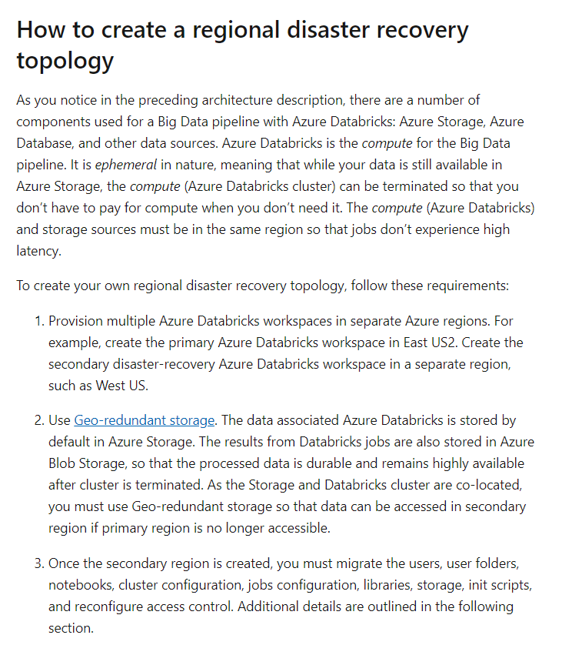

The other options as they won’t protect from a region-wide outage.

For more information on protecting against regional wide failure for Azure Databricks, visit the below URL-

* <https://docs.microsoft.com/en-us/azure/azure-databricks/howto-regional-disaster-recovery>

### **Question 50**

Domain :Design data processing solutions

You want to make use of Azure Stream Analytics. The Stream Analytics instance will be receiving data from IoT enabled devices. You need to send the data onto Cosmos DB.

Which of the following would you need to set in Azure Stream Analytics?

]A.

**A container input target**

]B.

**A Cosmos DB input target**

]C.

**A container output target**

]D.

**A Cosmos DB output target**

**Explanation:**

Answer – D

Since the data needs to go to Cosmos DB, we need to have a Cosmos DB output target.

The Microsoft documentation mentions the following.

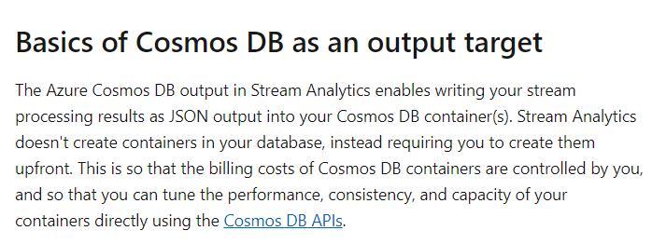

Since this is clearly mentioned in the documentation, all other options are incorrect.

For more information using Cosmos DB as the output target, visit the below URL-

* <https://docs.microsoft.com/en-us/azure/stream-analytics/stream-analytics-documentdb-output>

### **Question 51**

Domain :Design data processing solutions

You want to make use of Azure Stream Analytics. The Stream Analytics instance will be receiving data from IoT enabled devices. You need to send the data to Cosmos DB.

Which of the following needs to be created in Cosmos DB beforehand?

]A.

**A container**

]B.

**A document store**

]C.

**A file store**

]D.

**A table**

**Explanation:**

Answer – A

You would need to create a container beforehand. This is also mentioned in the Microsoft documentation.

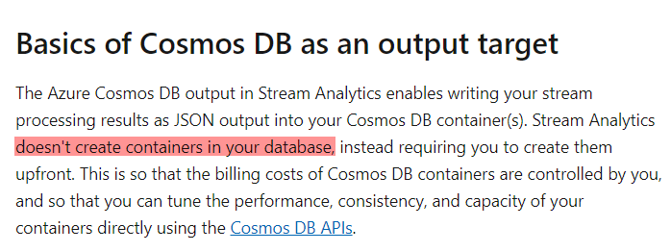

Since this is clearly mentioned in the documentation, all other options are incorrect.

For more information on using Cosmos DB as the output target, visit the below URL-

* <https://docs.microsoft.com/en-us/azure/stream-analytics/stream-analytics-documentdb-output>

### **Question 52**

Domain :Design data processing solutions

A company wants to design a data processing system. Data would be ingested via Kafta streams into Azure Data Lake Storage. The data needs to be processed by an Apache Spark-based analytics service.

The company decides to use Azure SQL Data Warehouse as the analytics service.

Would this fulfill the requirement?

]A.**Yes**

]B.**No**

**Explanation:**

Answer – B

Azure SQL Data Warehouse is a data warehousing solution. You need to use Azure Databricks.

For more information on Azure Databricks, visit the below URL-

* <https://docs.microsoft.com/en-us/azure/azure-databricks/what-is-azure-databricks>

### **Question 53**

Domain :Design data processing solutions

A company wants to design a data processing system. Data would be ingested via Kafta streams into Azure Data Lake Storage. The data needs to be processed by an Apache Spark-based analytics service.

The company decides to use Azure Databricks as the analytics service.

Would this fulfill the requirement?

]A.**Yes**

]B.**No**

**Explanation:**

Answer – A

Yes, this is the ideal service.

The Microsoft documentation mentions the following.

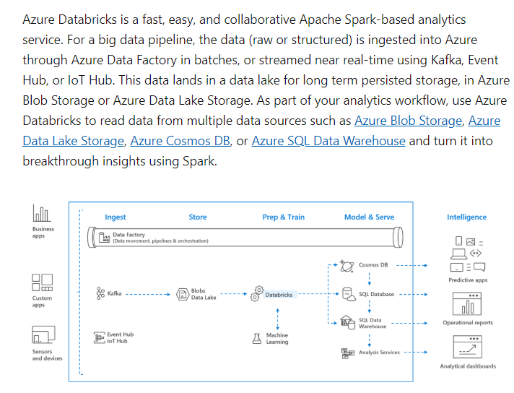

For more information on Azure Databricks, visit the below URL-

* <https://docs.microsoft.com/en-us/azure/azure-databricks/what-is-azure-databricks>

### **Question 54**

Domain :Design data processing solutions

A company wants to design a data processing system. Data would be ingested via Kafta streams into Azure Data Lake Storage. The data needs to be processed by an Apache Spark-based analytics service.

The company decides to use Azure Stream Analytics as the analytics service.

Would this fulfill the requirement?

]A.**Yes**

]B.**No**

**Explanation:**

Answer – B

This is not a Spark-based analytics service.

You need to use Azure Databricks.

For more information on Azure Databricks, visit the below URL-

* <https://docs.microsoft.com/en-us/azure/azure-databricks/what-is-azure-databricks>

### **Question 55**

Domain :Design data processing solutions

A company wants to design a data processing system. Data would be ingested via Kafta streams into Azure Data Lake Storage. The data needs to be processed by an Apache Spark-based analytics service.

The company decides to use Azure Analysis service as the analytics service.

Would this fulfill the requirement?

]A.**Yes**

]B.**No**

**Explanation:**

Answer – B

This is not a Spark-based analytics service.

You need to use Azure Databricks.

For more information on Azure Databricks, visit the below URL-

* <https://docs.microsoft.com/en-us/azure/azure-databricks/what-is-azure-databricks>